**✨** HISTORY OF THE PLCs

Before 1968, factories-controlled machines using **relay-based systems**:

* Relays = little electromagnetic switches turning things on/off.
* To control one motor, you needed a power relay.
* To control *that relay*, you needed control relays.
* Add timers, counters… soon you had cabinets stuffed with hundreds of relays.  
  👉 Result: a hot mess. Hard to wire, hard to change, a pain to troubleshoot. 🤯



Enter 1968 (Hydra-Matic division of General Motors):

* Replace relay logic with a **solid-state controller**.
* Must support **ladder logic** programming (familiar to electricians).
* Must handle **harsh industrial environments** (dust, vibration, electrical noise).
* Must be **modular** (easy to expand and maintain).

Dick Morley’s team delivered:

**Modicon 084** – first commercial PLC (limited success due to memory & speed issues). Too slow to perform any function anywhere near the relay response time. In it were a processor board, memory, and a “logic solver” board, which parsed the algorithms associated with ladder logic.



**Modicon 184** – Robust, user‑focused design that turned PLCs into an industry standard. It ignited the market and began the changeover from relay-based control to solid-state units.



Key innovation:

Instead of physically rewiring circuits, engineers now just modify software logic.  
✅ Faster changeovers.  
✅ Reduced downtime.  
✅ Lower maintenance.  
✅ Space-saving, scalable control.

💥 Nick’s Fast Exam Lines:

*“Before PLCs, factories used complex relay-based systems that were expensive, huge, and hard to maintain.*

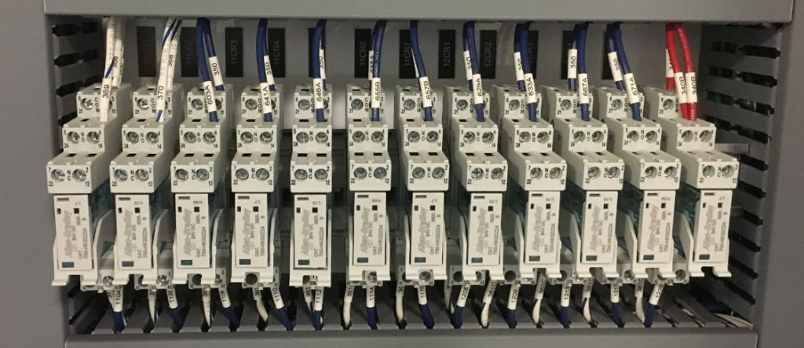

*In 1968, Dick Morley’s team created the first PLC (Modicon 084) to replace relays with a programmable, modular, solid-state controller. The breakthrough Modicon 184 later transformed automation worldwide.”*

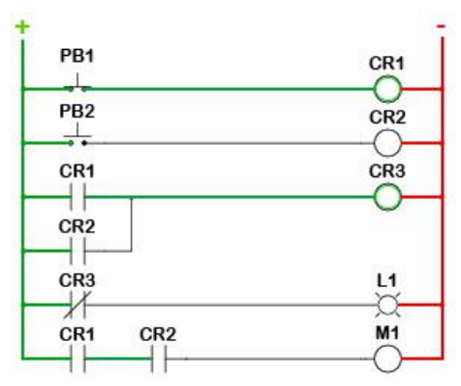

PLCS GROWING UP: FROM BASIC TO BOSS MODE! **📈**

The first PLCs were tiny, eager learners, fresh out of their "birth" phase.

They could handle the basics:

* **Inputs and outputs - turning things ON and OFF.**
* **Simple traditional relay‑style logic (coils and contacts).**
* **Basic Timers and counters.**

But just like a teenager hitting a growth spurt, PLCs quickly started adding some serious muscle and brainpower.

Leveling Up: New Powers for the PLC Brain **🧠✨**

The early PLCs were like a basic calculator, but they soon learned to do much more:

Math Whiz:

Since timers and counters already used "word size internal registers" (think of these as dedicated little memory slots for numbers), it was a natural next step for PLCs to start doing **simple math** – adding, subtracting, multiplying, dividing.

Soon after, they mastered **floating-point math**, allowing them to handle decimals and more complex calculations, which is super important for precise measurements.

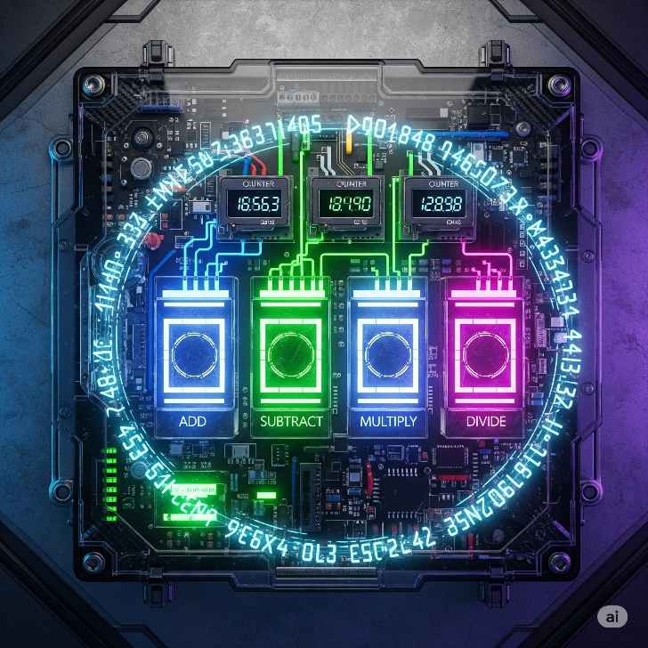

Enhanced Timing & Counting:

Beyond simple "start a timer for 10 seconds," PLCs gained **"one-shots"** (like a single-use trigger that fires once when activated) and more sophisticated timers and counters.

One-shot triggers and smart counters, letting them catch quick signal changes and control complex sequences more precisely.

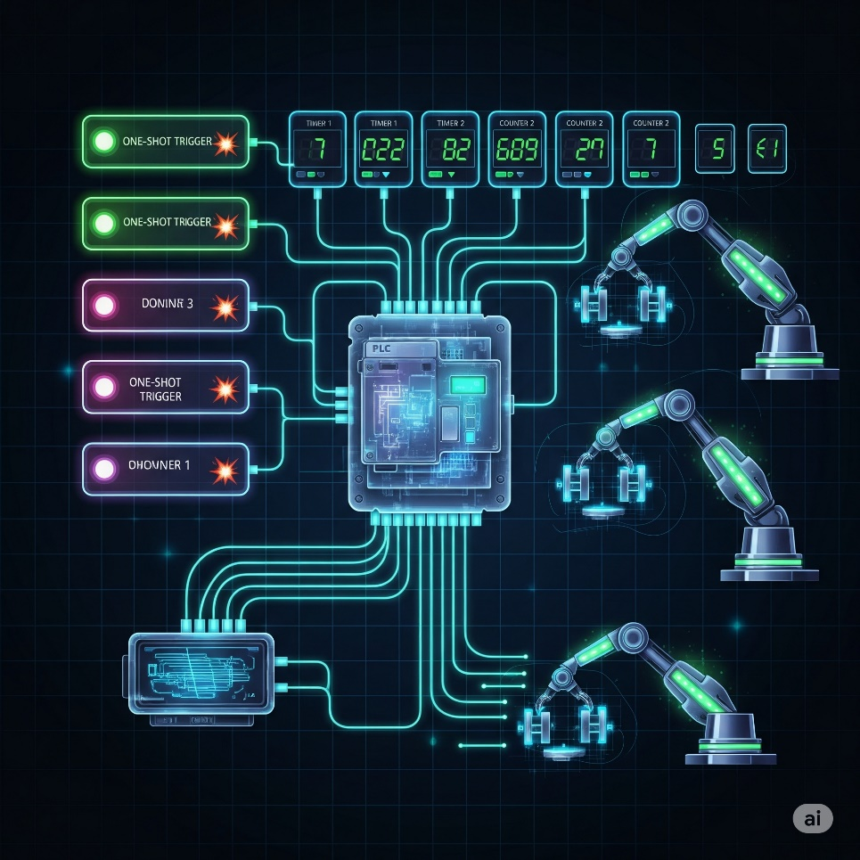

A bottling plant uses **smart counters** to track exactly how many bottles pass through each station, while **one-shot triggers** fire once to activate the capping machine only when a bottle is perfectly positioned.

Process Control Superpowers (PID):

PLCs gained built-in **PID controllers (Proportional-Integral-Derivative),** like having a lightning-fast autopilot that constantly fine-tunes systems to maintain perfect stability.

Imagine trying to keep the temperature of your shower *exactly* at 38°C. Without PID, you'd constantly be fiddling with the hot and cold taps, overshooting and undershooting, PID automatically keeps temperatures, pressures, and speeds exactly where they need to be, revolutionizing continuous processes in chemical plants, food production, and manufacturing.

A **pharmaceutical company** uses PID controllers to maintain precise pressure in tablet compression machines - as the powder density changes throughout production, the PID automatically adjusts hydraulic pressure to ensure every pill has exactly the same hardness and weight.

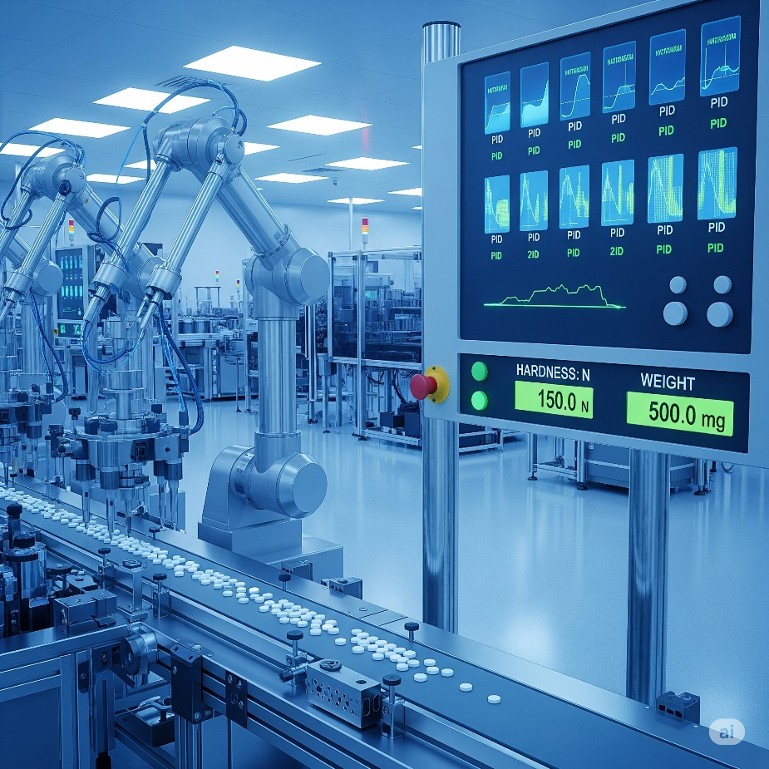

Drum Sequencers:

The OG rhythm masters of automation. These control machines that follow the same steps in order, every time. Like a car wash that automatically moves through: pre-rinse → soap → scrub → rinse → dry → wax.

Each step triggers specific actions and waits for completion before moving to the next, ensuring consistent results for any repetitive process.



Smarter Programming:

**Fill-in-the-blank data boxes:** Programming became more efficient. Instead of writing complex code for common functions, you could just fill in the blanks, like filling out a digital form.

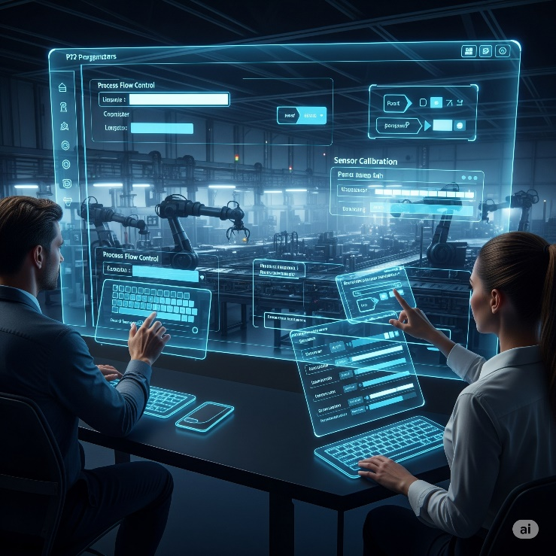

**Meaningful Tag Names:** This was a lifesaver! Instead of cryptic labels like "I:0/0" or "N7:0," engineers could use **descriptive "Tag Names"** like "Start_Button," "Conveyor_Motor_ON," or "Tank_Level_Sensor."



**Real-world analogy:** Imagine if all your contacts in your phone were just numbers instead of names. Tag Names are like giving your friends actual names so you know who you're talking to! This made programs way easier to understand, debug, and maintain, even for someone new to the project.



**Import/Export Tags:** The ability to easily move these Tag Names between different devices (like the PLC and an HMI) eliminated errors and saved tons of time from manually re-entering information. **Human Machine Interfaces** replace manually activated switches, dials, and other controls with graphical representations of the control process and digital controls to influence that process.



*We moved from hardwired panels to smart HMIs.* *Less physical clutter, more data visibility, fewer mistakes.*

TALKING THE TALK: PROGRAMMING & COMMUNICATION EVOLUTION **🗣️💻**

As PLCs got smarter, so did the tools used to program them and the ways they communicated with the outside world.

Programming Devices:

**The "Suitcase" Era:** Early programming devices were dedicated, clunky, and literally the size of suitcases! Not exactly portable.

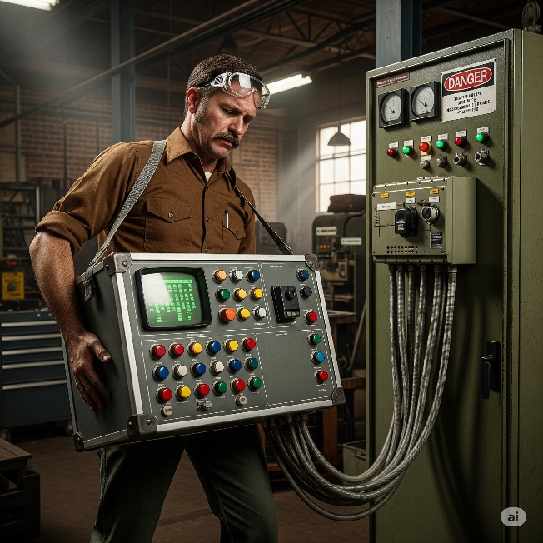

**Handhelds:** Then came smaller, handheld devices, offering a bit more freedom.

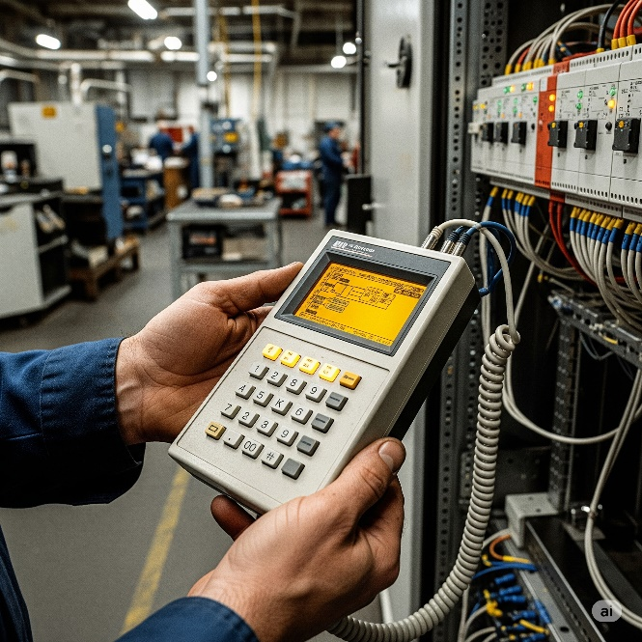

**PC Software Takes Over:** The real revolution happened when proprietary programming software moved to personal computers (PCs).

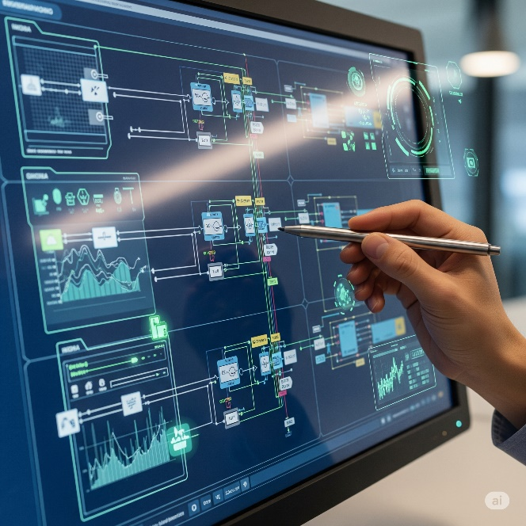

AutomationDirect's **DirectSOFT** was a pioneer as the first Windows-based PLC programming package. This was huge!



Having a PC meant:

* **Visual Programming:** You could see your ladder logic (or other programming languages) clearly on a screen.
* **Easier Testing & Troubleshooting:** PCs offered powerful tools for monitoring the PLC's status in real-time, simulating logic, and quickly pinpointing problems. It was like getting X-ray vision for your machine's brain.

Communication Protocols:

PLCs needed to talk to other devices, and this area saw rapid growth.

1. The Early Days (MODBUS & RS-232): Communication started with basic serial protocols like MODBUS over RS-232 (think of an old-school serial cable connecting two devices directly).

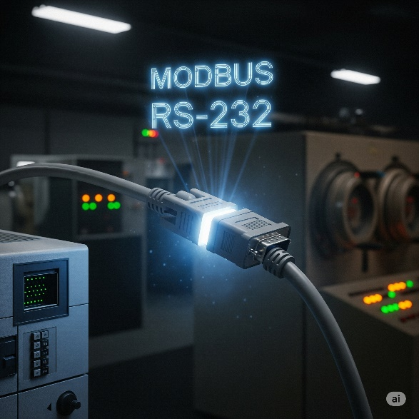

2. Expanding the Network (RS-485, DeviceNet, Profibus): As automation grew, so did the need for PLCs to talk to *many* devices over longer distances. This led to protocols like RS-485, DeviceNet, and Profibus. These new protocols were like setting up a small office network where multiple devices could chat.



**Industrial cables** branch out like highways, each carrying data through protocols like **RS-485, DeviceNet, and Profibus**.

**Sensors** act as the factory's eyes and ears, constantly monitoring temperature, pressure, and product presence. **Drives** function as muscles, controlling motor speed and direction. **Remote I/O modules** serve as nerve endings, extending the PLC's reach across the factory floor.

**Data pulses** flow along these lines like a digital heartbeat, making the invisible network work visible. The blue and orange lighting emphasizes how advanced industrial automation has become.

These **communication protocols** connect everything together, letting the PLC manage hundreds of devices across massive factory operations.

3. The Ethernet Era:Ethernet became the standard for industrial communication through protocols like EtherNet/IP. It's fast and lets PLCs connect with drives, robots, and touchscreen interfaces, creating smart factories where everything talks to each other.

PLCs evolved from simple relay replacements into powerful controllers that handle complex math, manage processes, and communicate with other machines - becoming the backbone of modern industry.

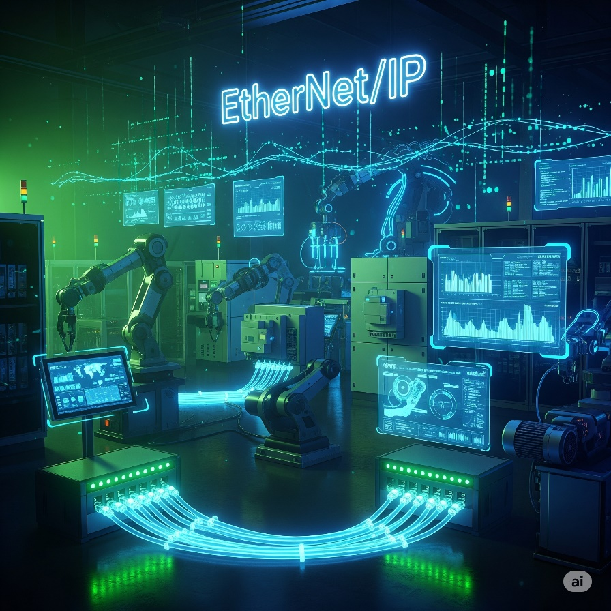

HOW TO CHOOSE YOUR CONTROLLER: THE "SMART BRAIN" CHECKLIST **🧠✅**

Choosing the right "brain" for your machine or system isn't just about grabbing the first thing off the shelf.

It's like picking the perfect teammate for a big project – you gotta consider a few key things to make sure they're a good fit!

This checklist is your cheat sheet to figure out what kind of programmable controller your project actually needs.

Step 1: New System or Existing System? 🏗️🔄

Are you building from scratch or adding to something already running?

**Why this matters:** It's like trying to connect a PlayStation 5 to an 80s TV - different tech doesn't always play nice together. Your new controller needs to communicate with existing equipment, or you'll have expensive paperweights.

**Pro-tip:** Check compatibility before buying to save headaches and money.

A factory tries to connect a new Allen-Bradley PLC to existing Siemens motor drives. The **Allen-Bradley** uses EtherNet/IP while the **Siemens** **drives** only speak Profibus - they literally can't communicate without **expensive gateway** converters, turning a simple upgrade into a costly nightmare.

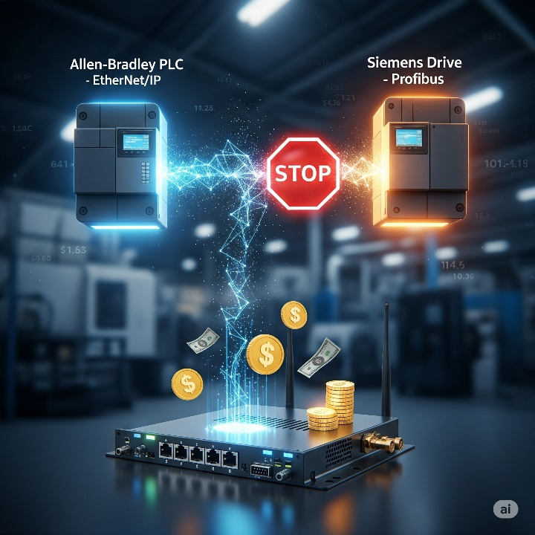

Step 2: Battle the Elements! (Environmental Check) **🌡️💨**

Where will your controller live? Nice air-conditioned office or hot, dusty factory floor? Consider things like:

* **Temperature:** Is it going to be super hot or freezing cold? 🔥❄️
* **Dust & Dirt:** Is the air full of grime, sawdust, or metallic particles? 🌬️
* **Vibration:** Is it going to be constantly shaking from heavy machinery nearby? ⚙️
* **Facility Codes:** Does your workplace have any special rules or safety codes about equipment (like needing to be explosion-proof)? 🚧
* **Why this matters(seriously!):** Imagine trying to use your smartphone in a sauna, or trying to take it deep-sea diving without a waterproof case. It's probably not gonna last long, right? 😬

Standard controllers work in 0-55°C (32-130°F), but extreme heat, dust, or constant shaking will kill them.

Choose ruggedized controllers for harsh environments or protect standard ones with proper enclosures. Skip this step and your whole operation stops when the controller dies.

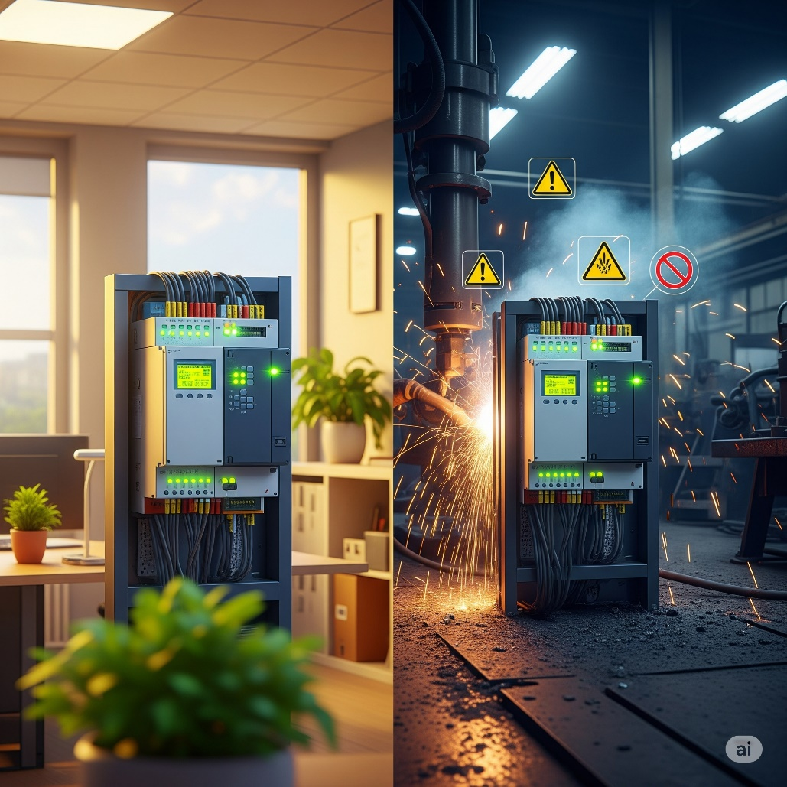

Step 3: Counting the "On/Off" Crew (Discrete Devices) **🚦**

Think about all the things in your system that are just **ON or OFF**. These are called **discrete devices**.

**What to figure out:** How many discrete devices do you have, and do they use AC (wall power) or DC (battery power)?

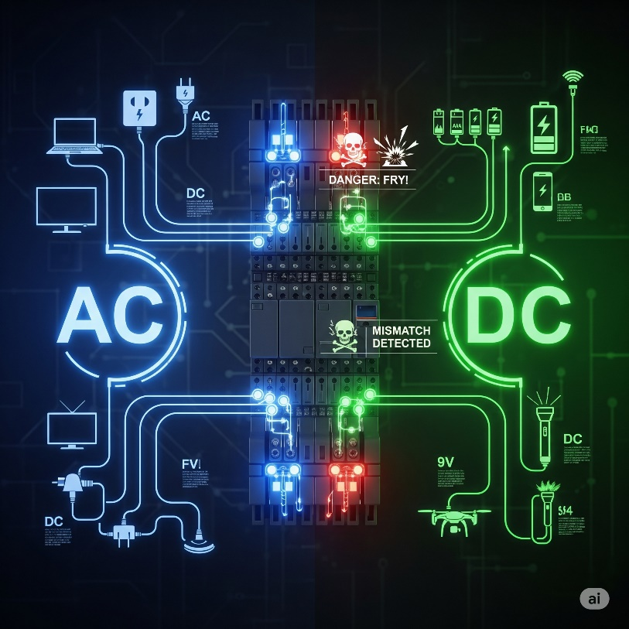

**Why this matters:** Your controller is like a switchboard - each device needs its own connection point. If you have 50 buttons and lights, you need 50 I/O points. Plus, AC devices won't work with DC controllers without frying something.

**Your move:** Count all on/off devices and note if they're AC or DC to determine your I/O requirements: buttons, lights, motors starting/stopping.

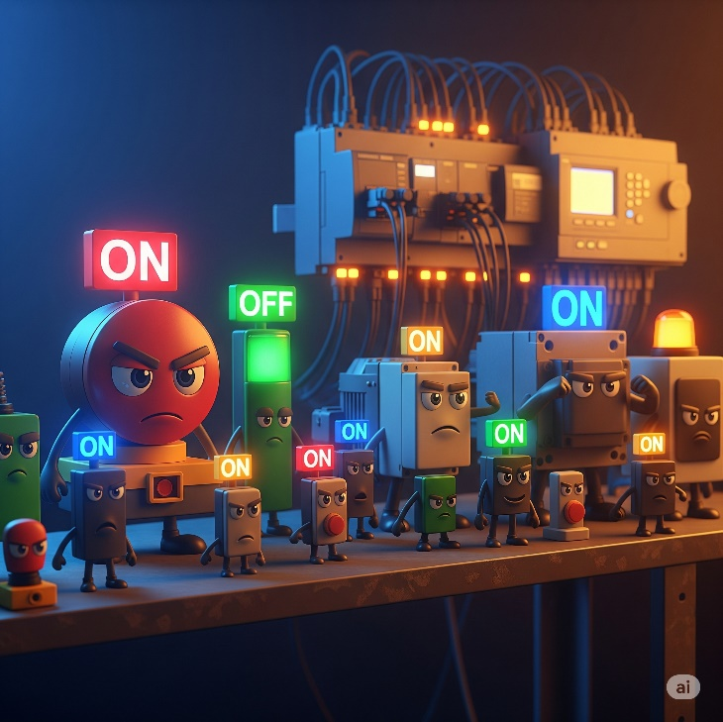

Step 4: Count Your Measuring Devices (Analog Devices) **📏🌡️**

Count devices that measure range of values, not just on/off. These are your **analog devices** e.g. A temperature sensor that tells you it's 25.3°C, a pressure sensor that reads 75.5 PSI, or a flow meter that says you have 10.2 liters per minute. These give you a continuous, precise measurement.

What to figure out:

How many of these "measuring" devices will your system have? And what kind of signal do they send (like voltage, current, or a direct temperature reading)?

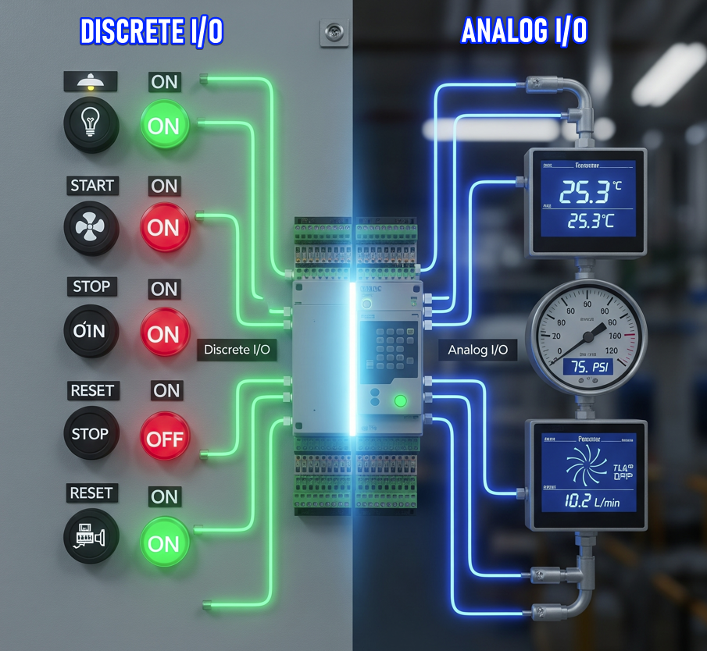

Why this matters:

A **discrete signal** is simple: ON or OFF (like a light switch).

An **analog signal** is continuous: it varies smoothly, like temperature 0–100°C or pressure 0–10 bar.

Your PLC needs **special analog input/output (I/O) modules** to read those continuous values or to send out continuous control signals.

If your PLC only has discrete I/O points, it can’t understand a temperature sensor that outputs 4–20 mA—it would be like trying to watch a 4K webcam through a port that only handles old‑school black‑and‑white signals. It just won’t work.

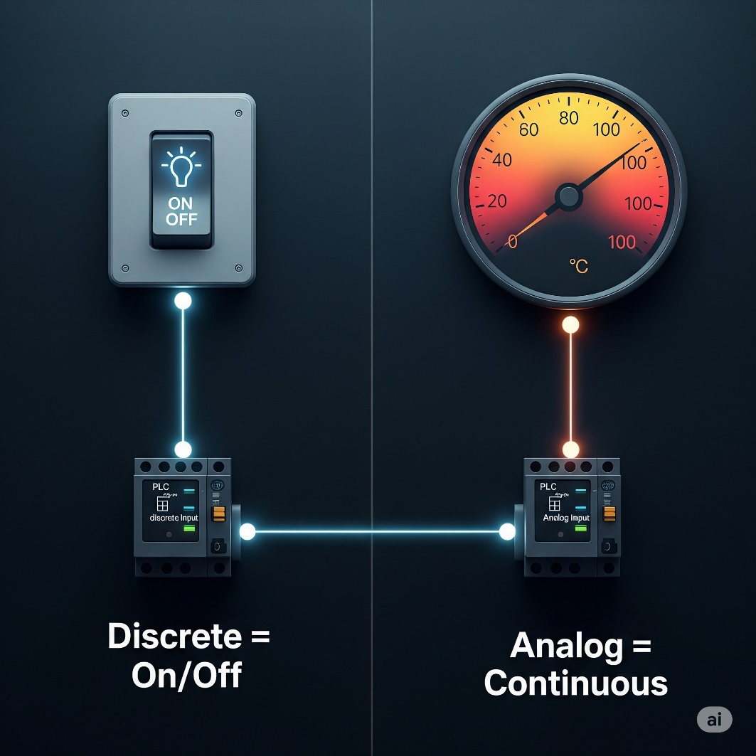

Your move:

**Make a list of every measuring device you plan to connect to your PLC, and note what kind of signal it uses.**  
For each sensor, ask:

* Is it **discrete** (on/off)?
* Or **analog** (variable voltage/current)?
* If analog, what’s the range (e.g., 0–10 V, 4–20 mA)?

💡 Why? Because when you know the exact mix, you can pick a PLC with enough **analog I/O points** (and the right types) to handle all those sensors.  
If you don’t plan ahead, you might buy a PLC that can’t read half your devices—then you’re stuck buying extra modules or a whole new PLC. Ouch.

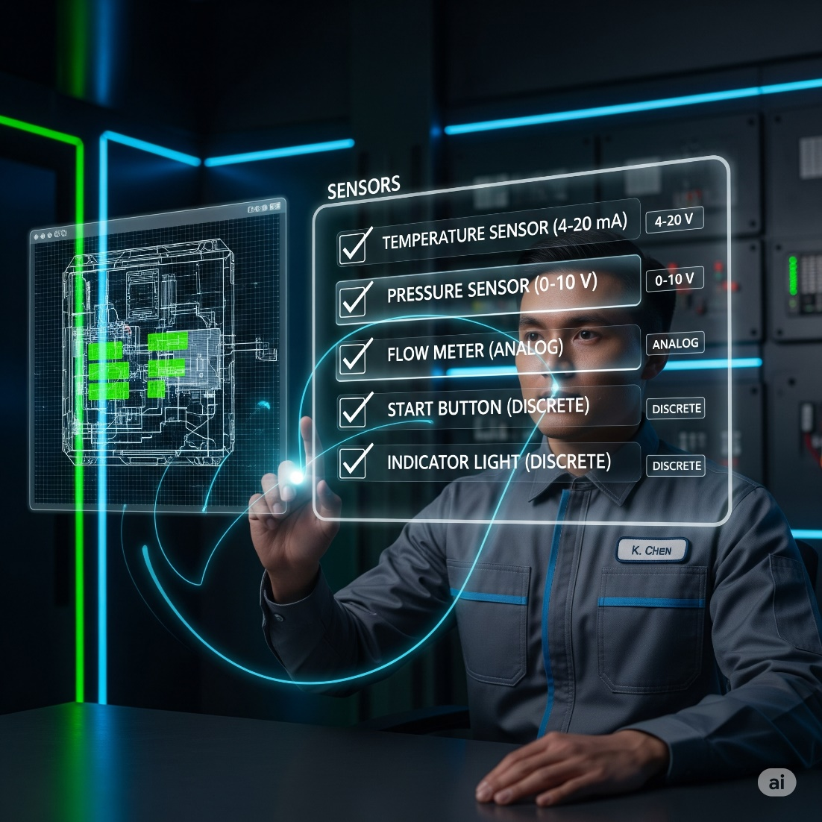

Step 5: Special Features Check **✨🚀**

Does your system need any fancy tricks beyond basic on/off control?

**Examples:**

* **High-speed counting:** Tracking thousands of products per second on fast conveyors
* **Precise positioning:** Robot arms placing components within fractions of millimeters
* **Real-time clock:** Time-stamping events or scheduling automatic operations
* **Special communication:** Connecting to specific networks or motion control systems

**Why this matters:** Basic controllers are like smartphones - great for general tasks. But specialty functions need extra "apps" (modules) to work, just like professional photo editing needs special software.

**Your move:** List all special requirements early. High-performance features usually require expensive add-on modules that aren't included in standard controllers.

**Real-world example:** A bottling plant needs to count 2,000 bottles per minute passing through quality inspection. A standard PLC input can only handle about 100 counts per second, so it would miss most bottles. They need a **high-speed counter module** that can accurately track 500+ counts per second to catch every single bottle for proper quality control.

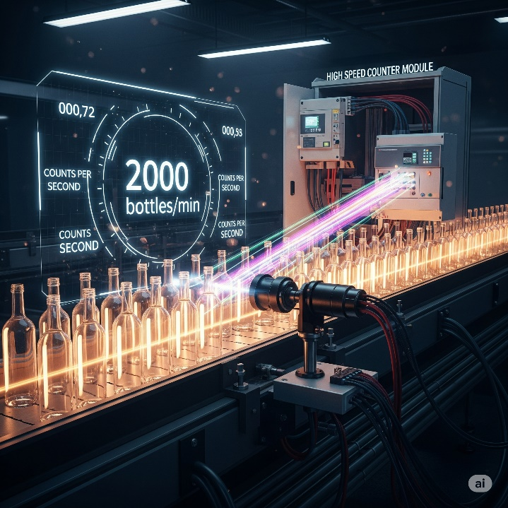

Step 6: CPU Power Check **💻⚡**

Choose your controller's "brain power" - like picking between a basic laptop for emails or a gaming rig for heavy tasks.

**Data Memory:** Temporary storage for all the live numbers your system is tracking right now - sensor readings, counter values, and timer settings.

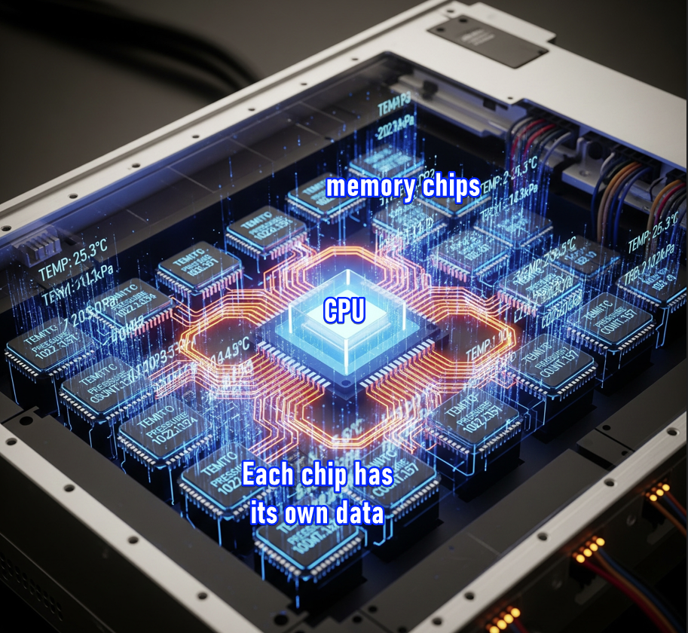

**Why it matters:** Systems that track lots of values or keep histories (like weekly production counts) need more data memory. Heavy data logging determines which CPU model you need.

**Program Memory:** Where your actual program instructions live permanently - like a hard drive storing all your code.

**Why it's important:** Every instruction ("start motor," "wait 5 seconds," "count product") takes up memory space. Complex programs need more program memory.

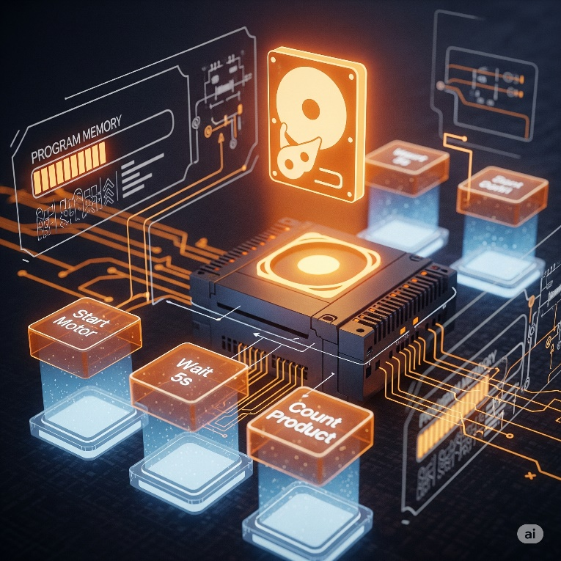

**Quick estimate:** Simple on/off devices need about **5 words per device**. Measuring devices need about **25 words per device**. Complex projects may need more.

A **"word"** is a unit of memory measurement in PLCs - think of it like a small storage box that holds one piece of information, typically 16 bits of data.

**Real-world example:** A simple bottling line with 20 on/off devices (start/stop buttons, motors, lights) and 4 measuring devices (temperature sensors, flow meters) would need roughly:

* **20 devices × 5 words = 100 words**
* **4 devices × 25 words = 100 words**
* **Total: ~200 words of program memory**

So, you'd need a PLC with at least 200+ words of program memory capacity.



**How fast does it need to be? (Scan Time):** How quickly the PLC CPU reads inputs, runs your program, and updates outputs - like how fast your computer processes clicks.

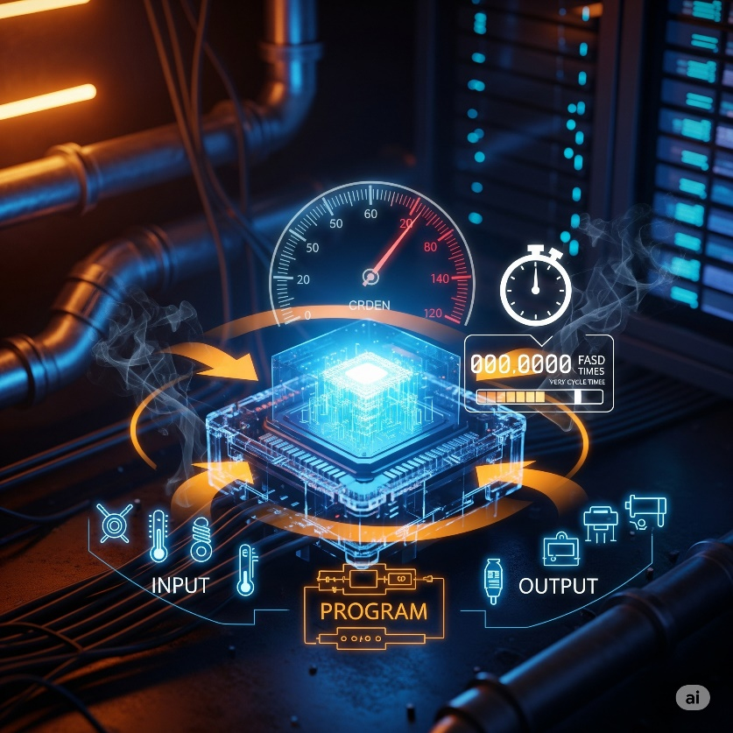

**Why it's important:** High-speed operations (like fast packaging lines) *need quick scan times.* Slow CPUs miss events or react late, messing up your process.

**Pro-tip:** Some CPUs are fast at simple on/off logic but slower at complex math. If you need **PID control** (like that perfect shower temperature), choose CPUs designed for heavy calculations - they'll save you major headaches.



Step 7: Where Are Your Devices Located? **📍🌐**

Are all your sensors, buttons, and motors close to the main PLC/controller, or spread across a big factory or different buildings?

**Remote I/O:** Devices are far away, so you use small connection boxes near the devices that talk back to the main PLC through one cable – similar to using Wi-Fi extenders across a big office.



**Why this matters:** Running hundreds of individual wires across long distances is expensive and a nightmare. Remote I/O uses one communication cable instead.

Wi-Fi extender broadcasts your internet signal further, **Remote I/O modules extend the PLC's ability to communicate with devices that are far away from the main control cabinet.**

**How it works:** Remote systems use industrial networks like **Ethernet** or **serial communication** with protocols like **Modbus** to send data back and forth.

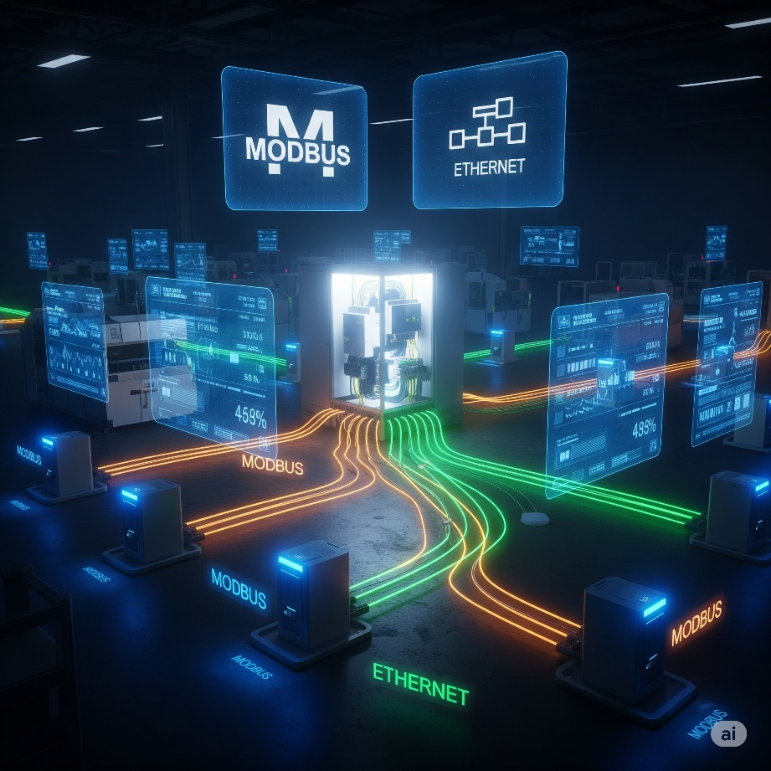

The main PLC is too far away to connect directly to all the devices, so:

1. **Remote I/O modules** are placed close to the distant devices.
2. These modules collect data from local sensors/control local motors.
3. They use protocols like **Modbus, Profibus, or Ethernet** to send all that collected data back to the main PLC through one communication cable.
4. The main PLC processes everything and sends commands back to the remote modules the same way.

So yes - the remote I/O modules act as "messengers" that gather local device info and relay it to/from the distant main PLC using these industrial communication protocols.

**Your move:** Count how many separate locations have devices. Multiple locations = you need remote I/O capability.

Step 8: Who Needs to Talk to Whom? (Communication Requirements) **🗣️💬**

Your PLC doesn’t live in a bubble. Besides handling its own inputs and outputs, it might need to “talk” to other brains in the system. Before you pick a PLC, figure out **who it needs to communicate with**.

**🔗** What kinds of communication are we talking about?

* **PLC ↔ PLC:**  
  Sharing data between two or more PLCs so they can coordinate tasks.
* **PLC ↔ SCADA / MES / ERP:**  
  Sending production info up to higher‑level systems like SCADA (for monitoring) or an ERP system (for business management).
* **PLC ↔ Smart Devices:**  
  Directly communicating with smart sensors, barcode scanners, or advanced motor drives.

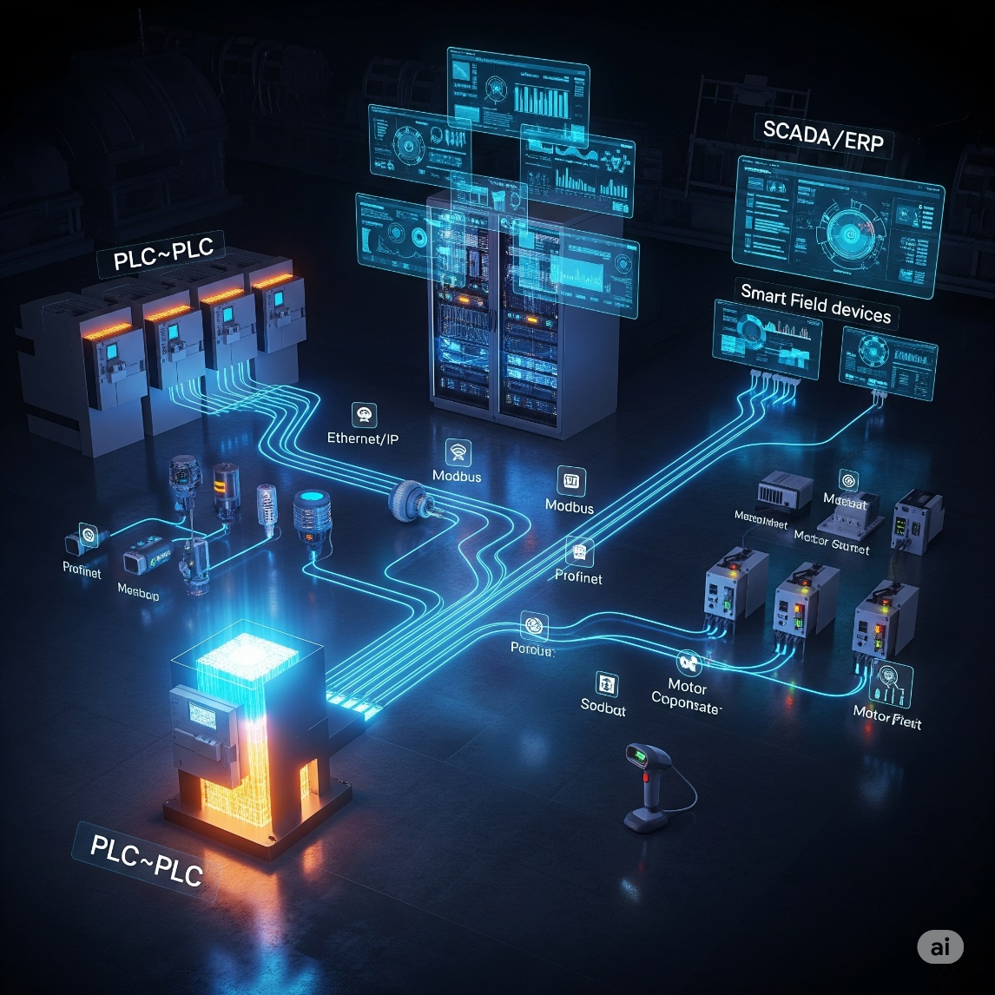

**🎯** Your mission:

Identify *all* the other systems or devices your PLC needs to exchange information with. Don’t assume—write them down.

**⚠️** Why this matters:

Not every PLC comes loaded with multiple communication ports or protocols.  
Think of it like buying a laptop:

* Some have HDMI, 4× USB, and Ethernet right out of the box.
* Others only have the basics, and you’ll need adapters.

If your PLC needs to handle heavy communication, you might:  
✅ Choose a CPU that already supports those protocols, **or**  
✅ Plan to buy extra communication modules.

**👀** Your move:

Make a clear list of every system or device your PLC must talk to.  
This list will guide you in selecting the right CPU and making sure you’ve budgeted for any additional communication hardware.

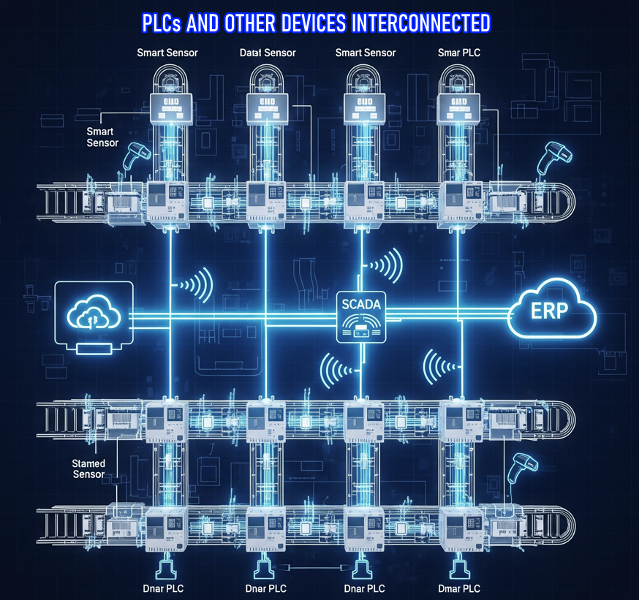

Step 9: Determining your Programming Requirements**✍️🤖**

**✨ Programming Requirements: Do You Need More Than the Basics?**

**Ask yourself:**  
Does your application only need traditional instructions (like timers, counters, and basic logic), or does it require special built-in instructions as well?

**Why this matters:**  
Not every controller supports every type of instruction.  
You must choose a PLC model that can handle all the instructions your specific application will need.

✅ Standard instructions (the basics almost every PLC can do):

* **Timers:** Count time (e.g., “wait 10 seconds before starting the motor”).
* **Counters:** Count events (e.g., “count 5 products, then trigger a conveyor”).
* **Basic logic:** Combine inputs and outputs (e.g., “If this button is pressed AND the sensor is clear, then run the motor”).

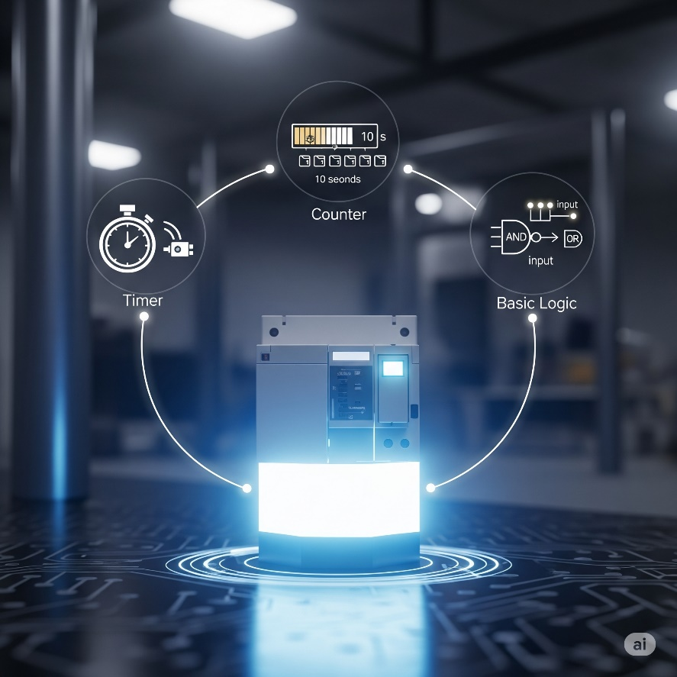

🚀 Special instructions (the advanced features):

Some PLCs include powerful ready‑made functions to save you from writing complex code yourself:

* **PID Control Blocks:** For smooth control like keeping temperature or pressure steady without you hand‑coding the math.
* **Motion Control:** For robots or machines that need precise movement or synchronization.
* **Recipe Management:** Quickly switching between different product setups without rewiring or rewriting code.
* **Database Connectivity:** Talking directly to databases to log data or fetch settings.

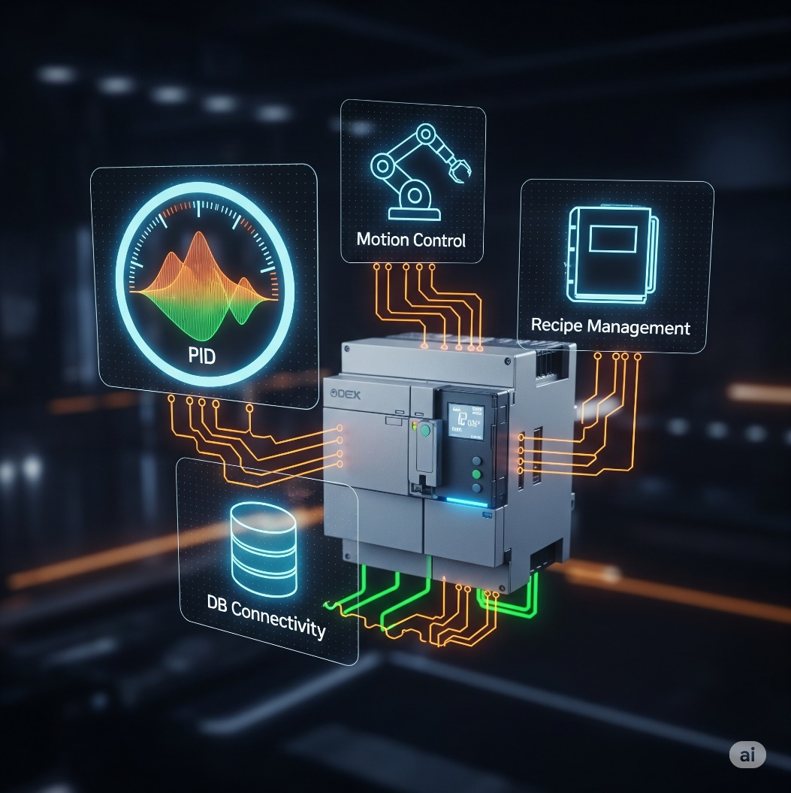

⚠️ Why this matters:

Not every PLC supports every special function.  
👉 **Pick the wrong model**, and you might end up trying to build complex control logic from scratch—frustrating, error‑prone, and time‑consuming.

👉 **Bad requirements reconnaissance** is a recipe for disaster, and it absolutely leads to your machinery "suffering" – which means poor performance, downtime, errors, and a whole lot of headaches.

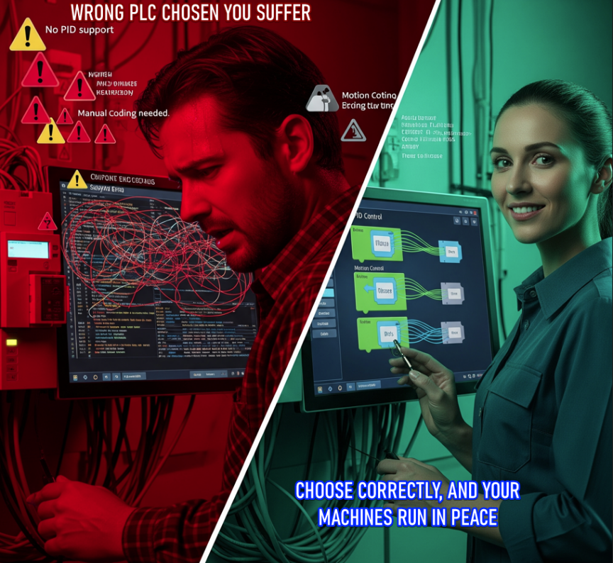

🎯 Your move:

Carefully review your application.  
👉 Make a list of any special instructions or advanced features (like PID, motion control, recipe management) that you’ll need, and confirm the PLC you choose fully supports them.